
STUDENT CASE STUDY EXECUTION REPORT
Department | CSE
Subject | DSA-2
Academic Year | I-III Semester (2025-26)
Faculty Name | Dr.N.Chaitanya Kumar
Student Name | K.V.A.Advaitha
Roll number | 2520030150
Branch | CSE
Course Outcome | CO-2

Case Study Topic: AirLink Passenger Traffic Analytics using Fenwick Tree
Work Done Summary:
In this project, we developed a Passenger Traffic Analytics System using a Fenwick Tree (Binary Indexed Tree). The system efficiently stores passenger traffic data and performs fast updates and cumulative count queries. By using logarithmic-time operations, the Fenwick Tree improves performance compared to traditional methods. This project demonstrated the practical use of Fenwick Trees in analyzing airport passenger traffic efficiently.
Implementation Details:
- Created a Fenwick Tree data structure.
- Stored passenger counts for different time intervals.
- Implemented update operation for new passenger arrivals.
- Implemented prefix sum queries for cumulative traffic.
- Calculated passenger statistics across multiple intervals.
- Verified correctness using sample airport passenger data.
- Analyzed performance and memory usage.
- Generated cumulative passenger reports.
Result:Screenshots/ Output
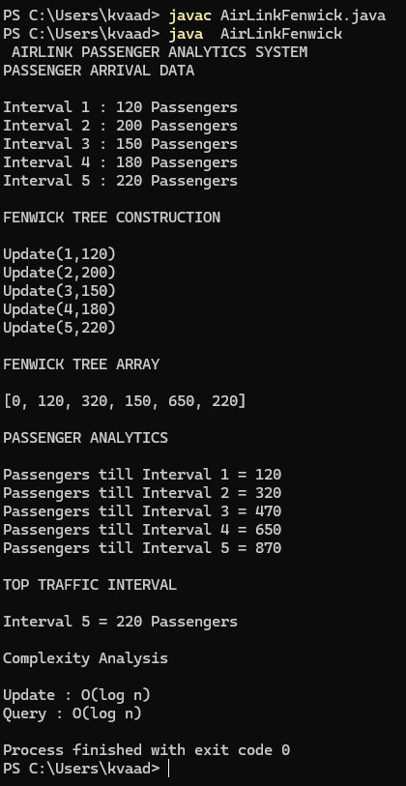
The Fenwick Tree successfully maintained cumulative passenger statistics and provided fast query processing.
Time Complexity:
- Update Operation : O(log n)
- Query Operation : O(log n)
- Space Complexity : O(n)
Compared with a normal array implementation, Fenwick Tree provides significantly faster cumulative statistics computation.

GitHub Link: https://github.com/advaitha-2307/AirLink-Smart-Airport-Operations-Flight-Management-System
Student Signature | Faculty Signature
________________________ | __________________________

